On my servers I installed Tmux, emacs, Fail2ban, Cowsay and lolcat.
I will show a picture of each of those for both servers and how to find them

Let’s start with CentOS
Tmux is installed

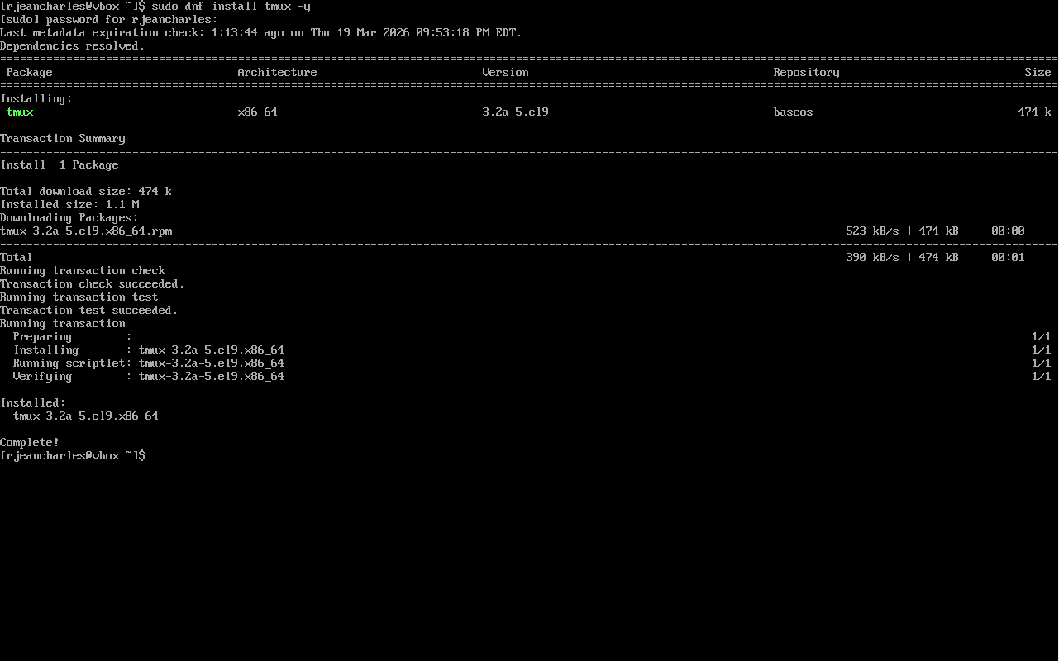

This how we can find Tmux on servers
Command use : tmux -V
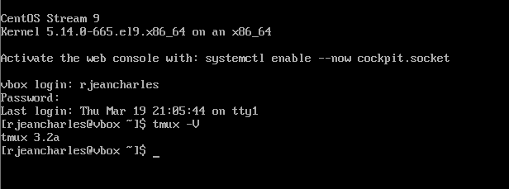

This how we verify where tmux is located
Command use : which tmux
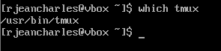

Emacs is installed
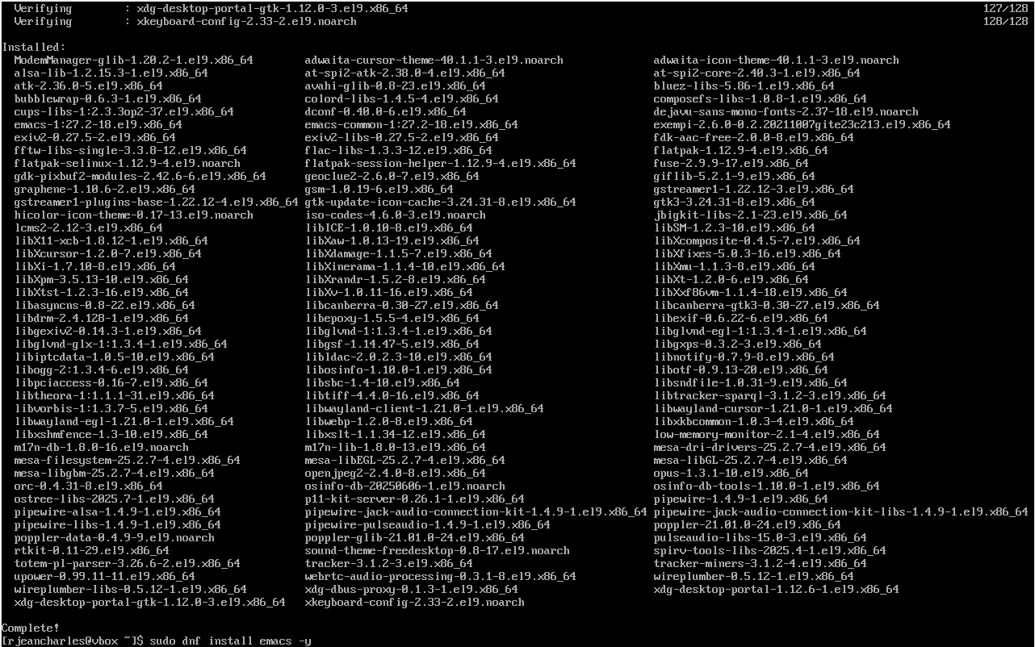

Where emacs is located
Command use : which emacs
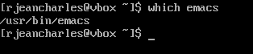

On this picture you will see the command dnf list installed is used for both tmux and emacs because it allows to show the packages are installed.

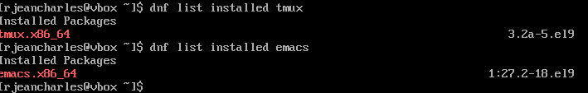

Fail2ban is installed
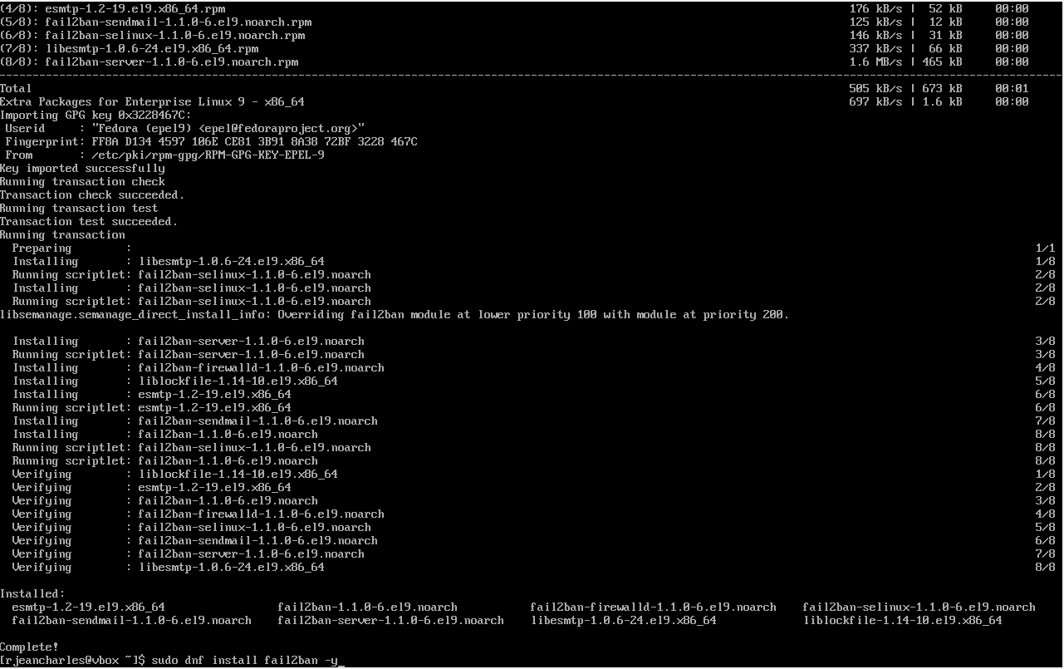

Fail2ban package is installed using command dnf list installed

Where fail2ban is located
Command use : which fail2ban-client
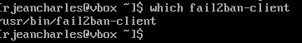
Fail2ban is run as a background service, the command fail2ban interact directly with it to make it run.

Cowsay is installed
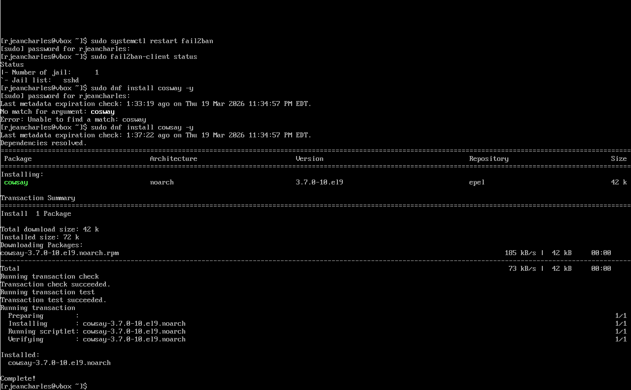

Show where it is located using which command
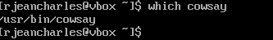

Verify that packages is installed using dnf list installed command
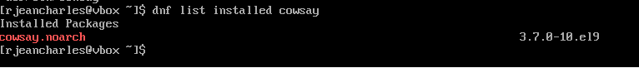

Lolcat is installed

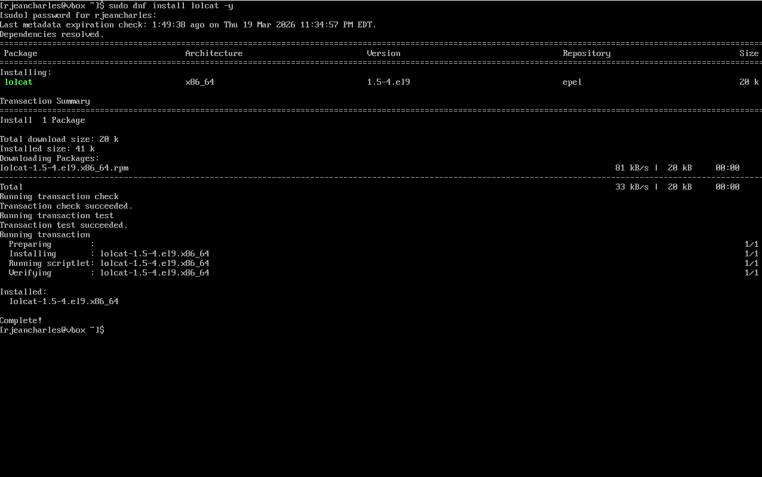

Where lolcat is located

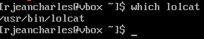

Verify is lolcat packages are installed
Vim is installed
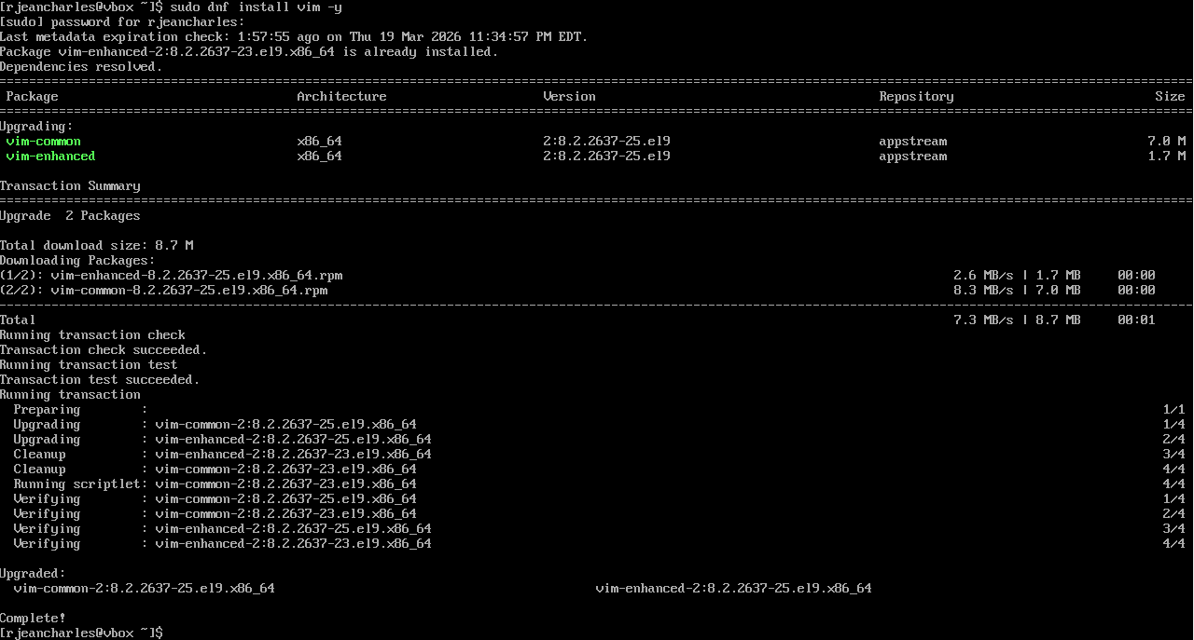

Where vim is located
Command use : which
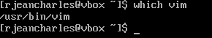
Since vim was already on the system using default package it’s not necessary to run dnf list installed command to look for packages

Ubuntu
Timux is already installed on the system. I do not need to reinstall it since this is a the new and latest version.
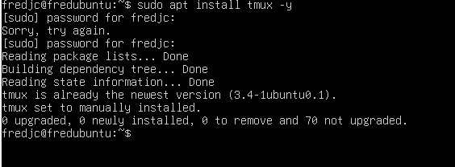
Timux is already installed on the system. I do not need to reinstall it since this is a the new and latest version.

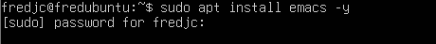
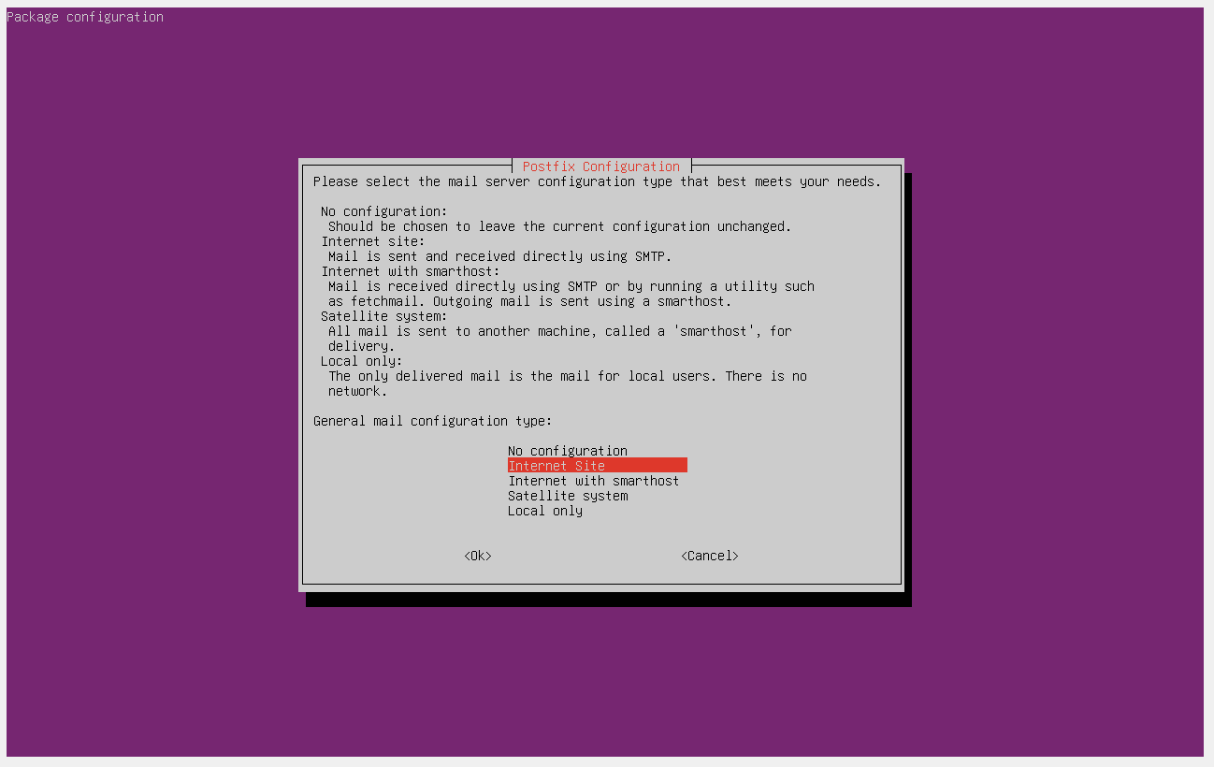
While installing, Postfix configuration appears. It is important to select local only because the system will not be use as a mail server
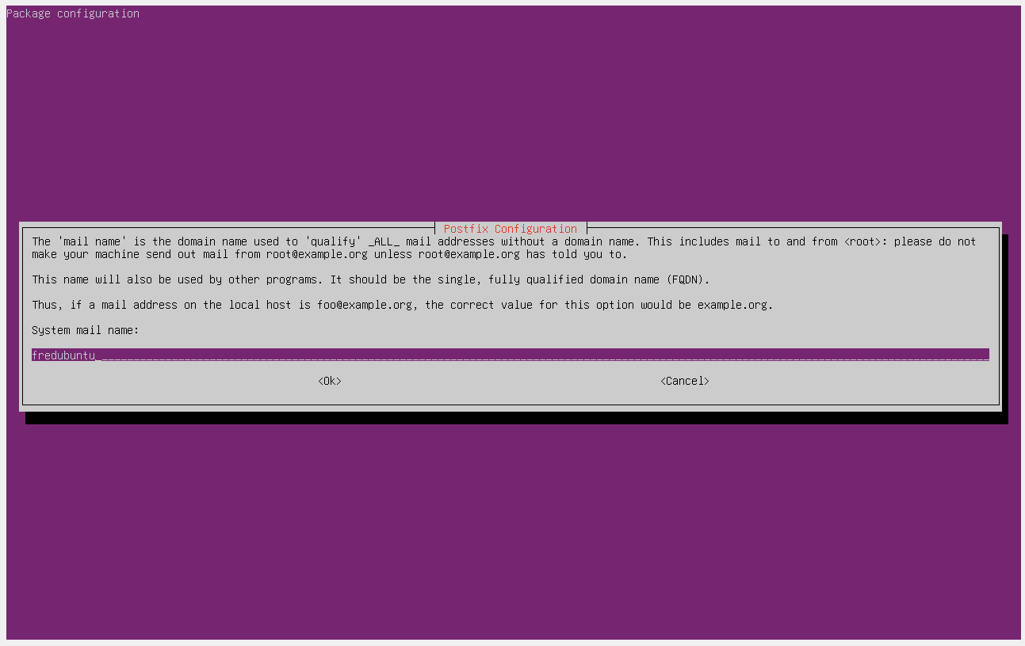
Here press Tab and click enter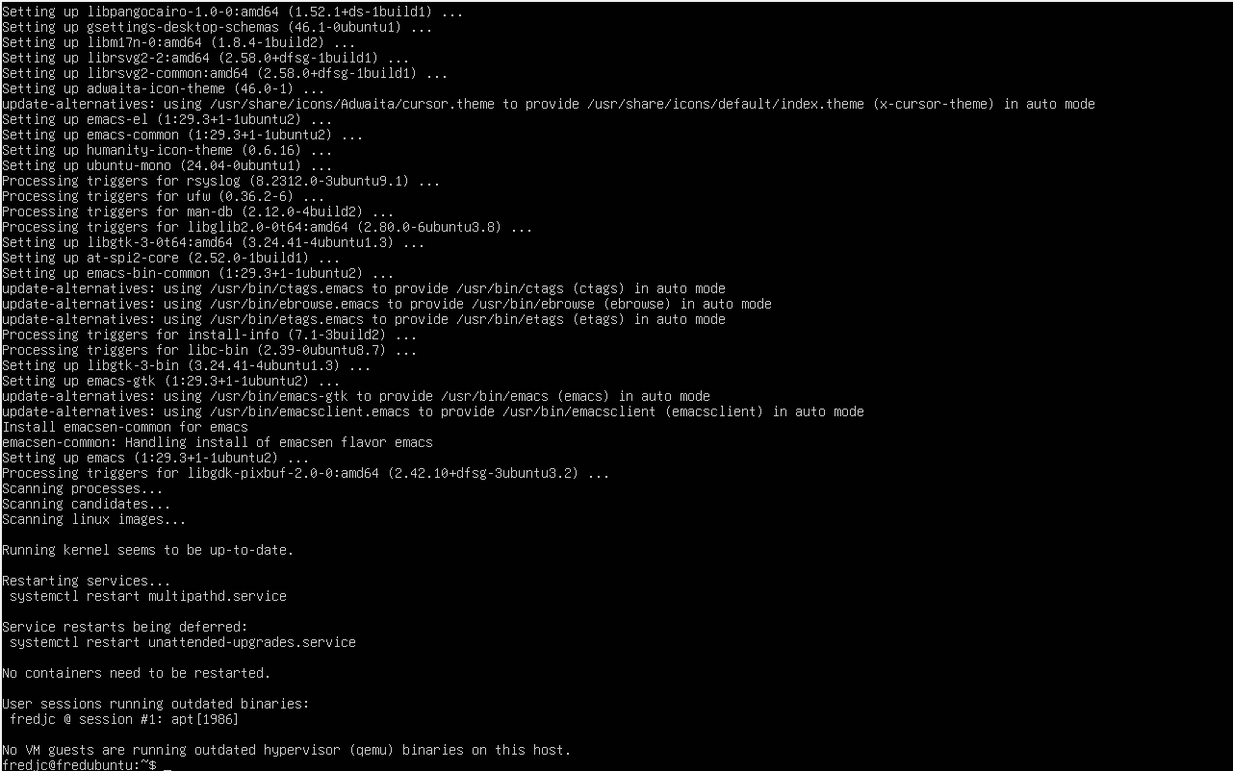The Installation is complete for emacs after configuring postfix, selected Local Only to not set up a mail server.

Installing Fail2ban

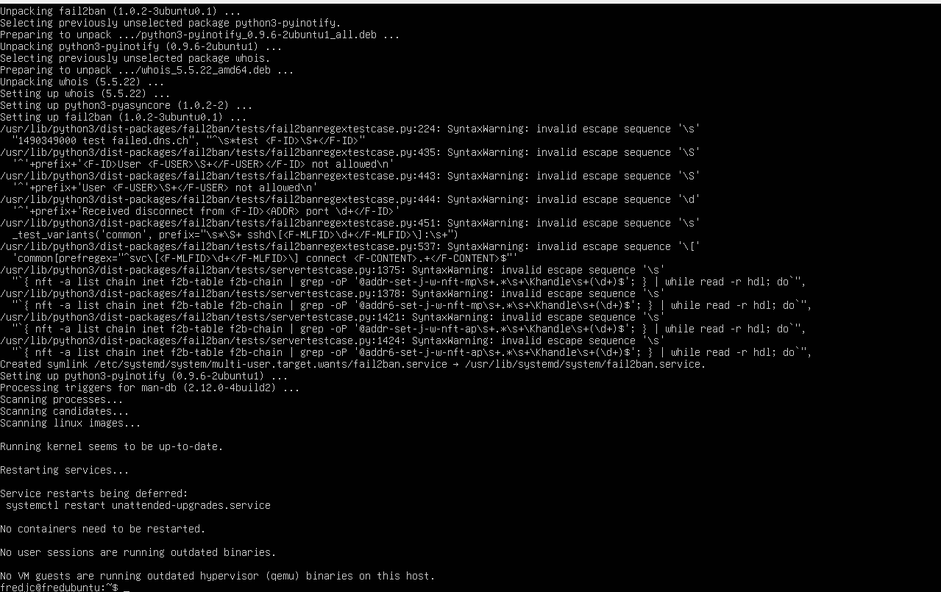
Fail2ban is completely installed
It is intalled without needing an additional repository unlike CentOS where EPEL were required.

Configuration on fail2ban

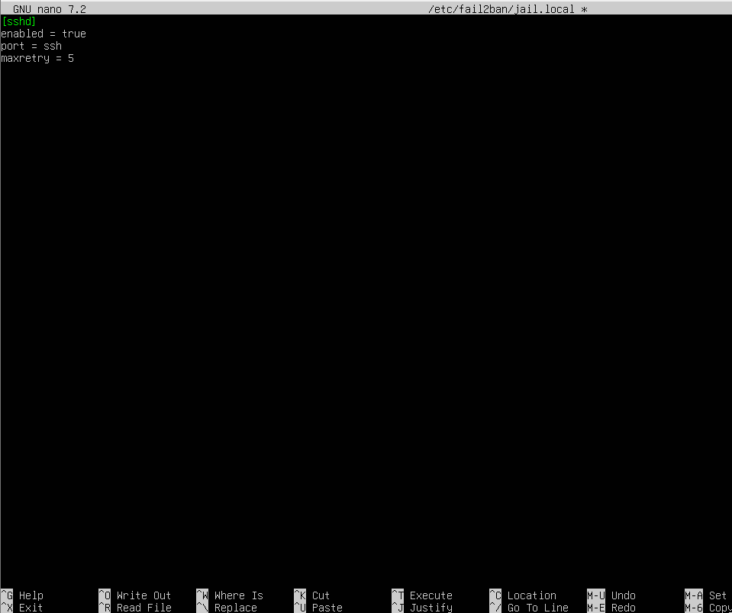
Save file

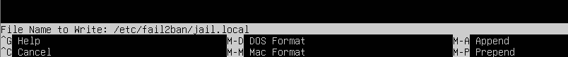

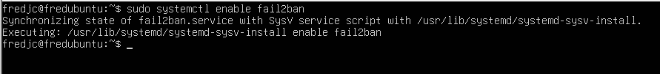

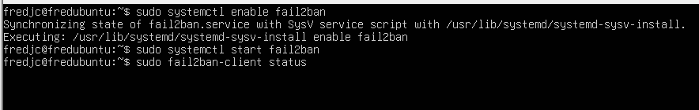
Run and verify If fail2bam is working
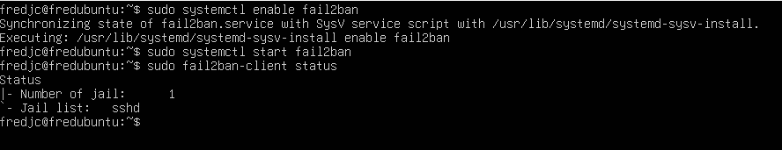
It actually working

Install Cowsay
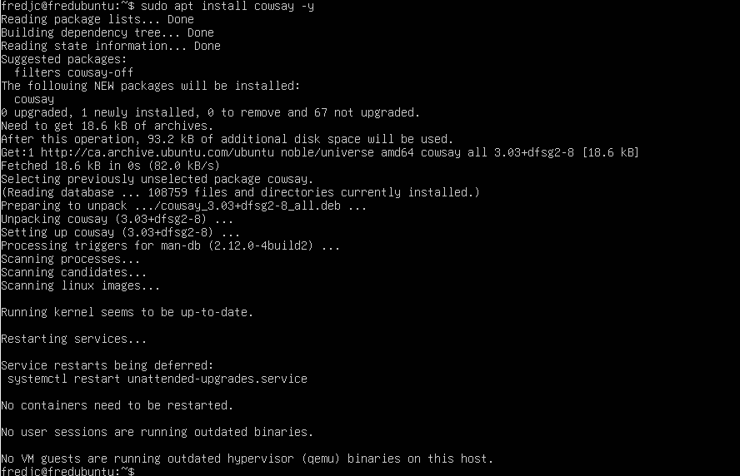

Verify Cowsay is installed
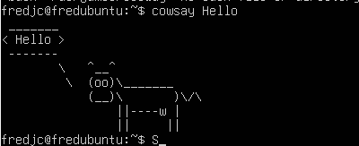
It’s working

Install lolcat

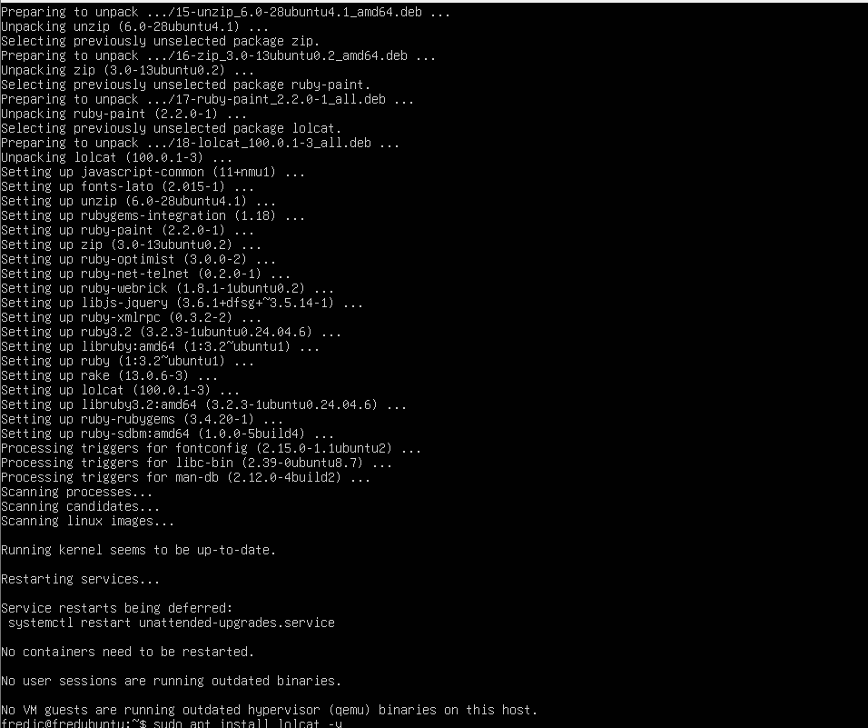

Verify lolcat is installed
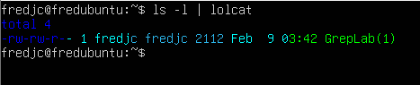

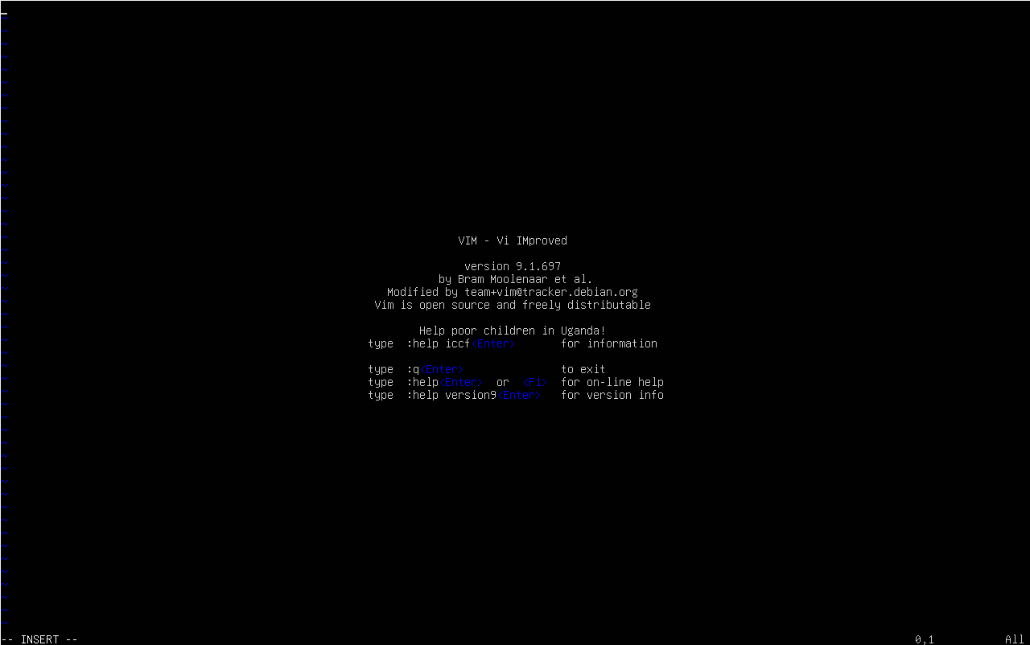

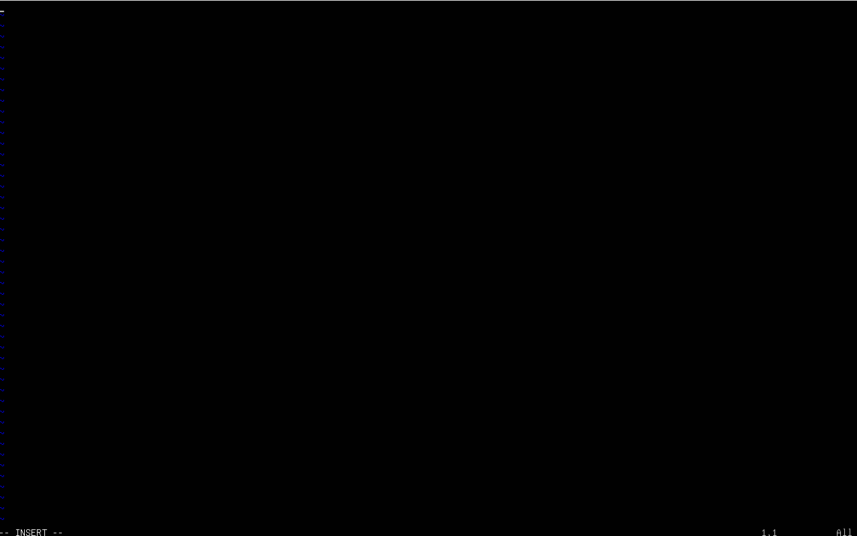

Create a file named new file with vim
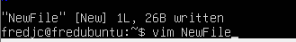

Verify if the file is saved
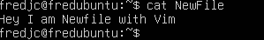

Sow how to find them on server and where they located
Command use : which
tmux
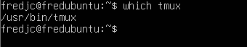
Emacs
Fail2ban
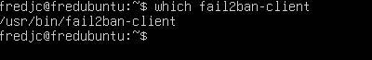
Cowsay
Lolcat
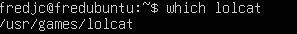
Vim
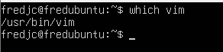

Just by curiosity this how you can change your password on ubuntu if you forget it
After restart the machine
Click on Esc
Go to advanced options
This screen will prompt

Choose this option
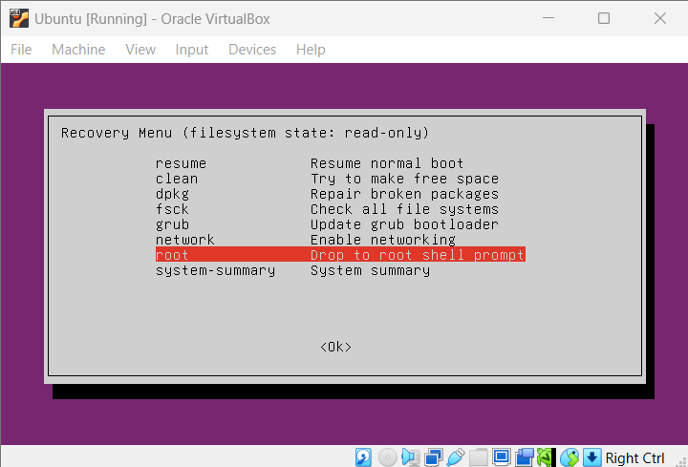

Press enter
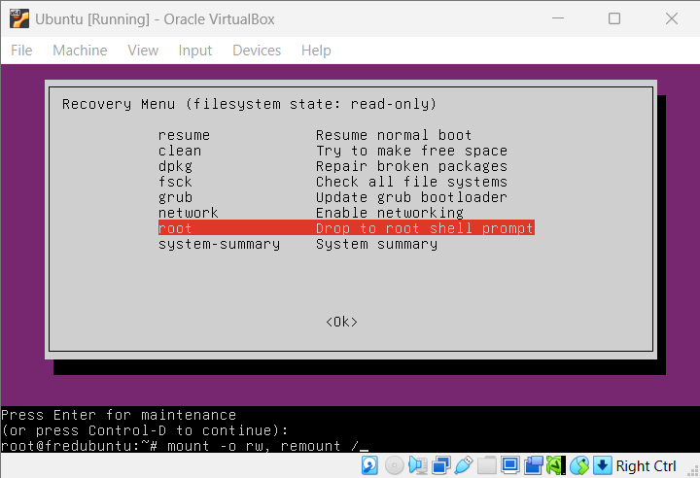

Type mount -o rw,remount /
It allows users to edit usernames and passwords
Enter password and type reboot
The screen will prompt the login page automatically
